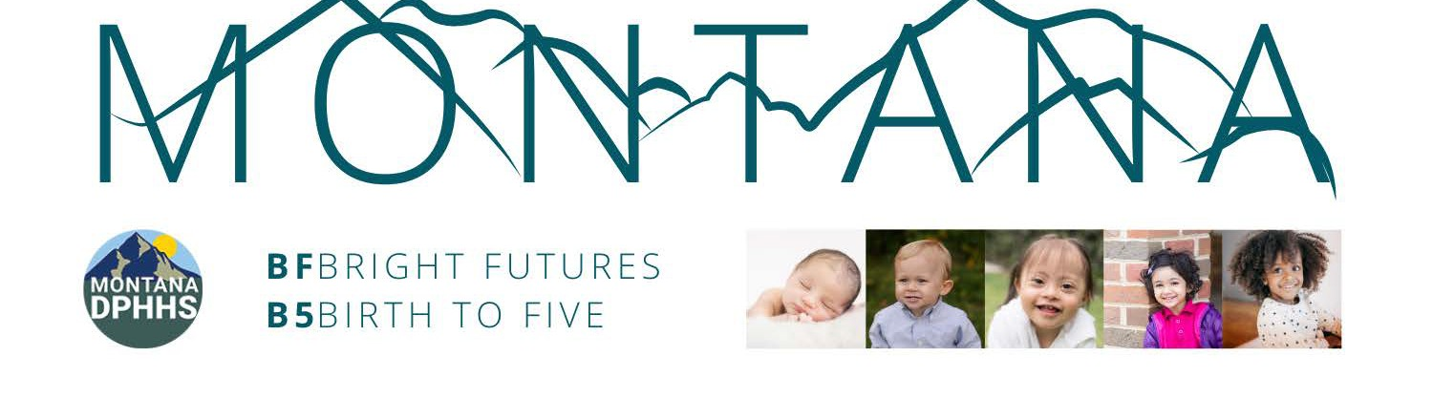

The State of Montana received the PDG B-5 Renewal Grant of $24 million over three years, 2023-2025. The grant serves as an exciting funding opportunity through the Administration for Children and Families (ACF) at the Department of Health and Human Services (HHS) and the Department of Education to support the Bright Futures B-5 Project in Montana.

The focus of the grant is building the early childhood system birth through age 5. The Early Childhood and Family Support Division is implementing a 3 year grant through December 2025. Below is a brief synopsis of anticipated outcomes, grant required activities, and project highlights.

# EXPECTED LONG-TERM OUTCOMES

1. Montana's families with young children have increased access to, and participation in high

quality early care and education across a mixed delivery system.

1. Montana's early childhood workforce is confident and effective, due to enhanced ECE professional development.
2. The early childhood system is coordinated to support effective family assessment, system navigation, care coordination, and use of data.
3. Montana's families are engaged and valued as partners in the early childhood system.
4. Montana's communities make early childhood a priority, and act to support children's health, learning, and well-being.
5. Montana's early childhood system is structured to support policy alignment, strategic financing, continuous improvement, and accountability.

# GRANT ACTIVITIES

1. Update needs assessment
2. Revise the strategic plan
3. Maximize parent and family engagement
4. Support the early childhood workforce and disseminate best practices
5. Support overall quality improvement
6. Enhance quality and expand access to existing and new programs
7. Monitor, evaluate, and use data for continuous improvement

# PROJECT HIGHLIGHTS

* + Universally Offered Home Visiting pilot
  + Child Care Expansion Pilot
  + Child Care Worker Subsidy Support program
  + Employer Recruitment and Retention strategies
  + Expand Apprenticeship and Pre-Apprenticeship programs
  + Professional Development Opportunities
  + Early Childhood Integrated Data system
  + STARS to Quality- redesign
  + Comprehensive Cost of Early Childhood System study

For additional information contact

Kathy Rich at [krich@mt.gov](mailto:krich@mt.gov)