Duties Direct Support Professionals are Allowed to Perform When Caring for Clients.

There are many duties that are required in order to provide adequate care for clients in services. Direct Support Professionals (DSPs) are expected to carry out many of those jobs with adequate training. Provider agencies must provide for the health and safety of the clients they serve but they have the option of choosing which tasks they feel their staff can safely perform. While the tasks listed below are things DSPs are allowed to do with adequate training, they are not required to perform these duties unless the agency policies allow them to do so as long as the agency is still able to provide for the client’s needs by other means. This paper will describe duties that can be performed by DSPs along with instructions to help with training staff.

# MEDICATION ASSISTANCE/ADMINISTRATION:

* 1. Medication certified staff are able to assist clients with all forms of medication except those that are injected or those that go through a tube (ARM

37.34.113 – CERTIFICATION OF PERSONS ASSISTING IN THE ADMINISTRATION OF MEDICATION: ADOPTION OF THE MEDICATION ADMINISTRATION MANUAL).

## Exceptions:

* + - In the case of an emergency, medication certified staff may inject

epinephrine into someone who has had an allergic reaction and may go into anaphylactic shock. There must be documentation of training for this procedure to staff who care for individuals with epinephrine orders.

* + - In the case of an emergency, medication certified staff may inject glucagon into a diabetic whose glucose level is dangerously low. There must be a protocol in place for the staff to follow and staff training on this procedure must be documented.

# MEDICATION CERTIFICATION

* + - To become medication certified, DSPs must be able to study and understand the information provided in the Medication Administration Manual. An open book written test must then be passed before a DSP can pass medications.
    - Medication certification expires after two years. Recertification is accomplished by taking and passing a certification test before it expires.

# EPIPEN® INJECTION:

1. Injection of epinephrine is generally effective in 5-10 minutes.
2. If symptoms aren’t improving or are worsening after 5 minutes, or if symptoms return, a second dose may be given.
3. Following the injection of epinephrine, seek emergency medical attention as a second reaction to the allergen can occur within hours.
4. Take used pen to hospital to show what was injected.
5. It works by: relaxing muscles, reversing swelling, stimulating the heart.
6. Side effects Include: pounding heartbeat, trembling, nervousness, headache, dizziness, nausea, and shortness of breath.

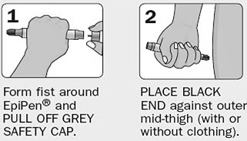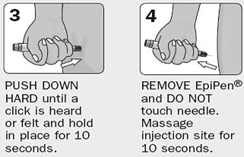

[www.pinterest.com](http://www.pinterest.com/)

# PROCEDURE FOR INJECTABLE GLUCAGON

Glucagon is needed when blood sugar levels are very low, and the person is not able to safely ingest oral glucose. There should be a protocol in place as to

when glucagon should be given. Note: some kits require mixing glucagon from

powder.

* 1. Remove needle protector and inject the entire contents of the syringe into the glucagon powder. Do not remove the plastic clip on the syringe.
  2. Remove the needle from the bottle.
  3. Swirl the mixture gently until the powder dissolves. The solution should be clear (do not use if discolored).
  4. Hold the bottle upside down and withdraw the contents into the syringe to the 1 mg mark on the syringe for adults and for anyone weighing over 44 pounds.
  5. With your thumb and forefinger about two inches apart on either side of the injection site, pinch up on the back of the upper arm, abdomen, thigh, or buttock.
     1. Insert the needle using one quick motion at a 90-degree angle (straight up and down).
     2. Press the plunger to inject; when empty pull it straight out.
     3. Turn the person onto side as they may vomit after the injection.
     4. Call 911 immediately after injection.
     5. Symptoms should resolve in 10 to 15 minutes.
     6. If the person doesn’t regain consciousness in 10 minutes, administer a second glucagon injection.

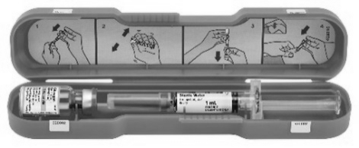

Ohio DDD med manual

# FEEDING TUBES:

1. All staff may assist with administering food through a gastrostomy tube (PEG or G-tube) once they have been properly trained.

* Bolus feedings: training may be done by other DSPs or licensed staff.
* Gravity feedings: training must be done by a licensed person (i.e. nurse) for each staff member with documentation of proficiency once training has been completed.
* Non-licensed staff may not administer feedings through a nasogastric (NG) tube, nasointestinal (NI) tube, or jejunostomy (J-tube).

1. Medication certified staff may administer medications through a gastrostomy tube (G-tube or PEG) once they have been trained to do so.
   * + Family members or guardians may train staff to perform this function.

They must then document that they have observed that the staff demonstrated adequate proficiency.

* + - If family or guardians are not able to train staff themselves, they can delegate that training be done by a licensed nurse. Delegation must be in writing. The nurse will train each staff person and document that training has been done and the staff is competent to perform the task.
    - DSPs may not teach other DSPs how to administer medications through a tube. Every new person who is going to be administering medications through the G-tube must be trained for this procedure by a family member or guardian or a delegated nurse.

1. Medication certified staff may **NOT** administer medications through a jejunostomy (J-tube). All feeding and medication administration must be done by licensed staff (nursing).
2. Medication certified staff may **NOT** administer medications through a nasogastric (NG) tube or nasointestinal (NI) tube. All feeding and medication administration must be done by licensed staff (nursing).

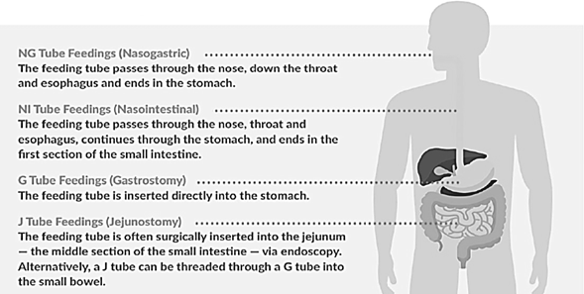

[peptamen.com/understanding-tube-feeding](https://www.peptamen.com/understanding-tube-feeding)

# NASOGASTRIC TUBE (NG TUBE):

* + - An NG tube can be used to give medications, liquids, and liquid food and is generally used for a short amount of time after abdominal surgery.
    - DSPs may not use an NG tube.
    - Problems associated with NG tube feedings include diarrhea, nausea, vomiting, abdominal cramps, swelling, injury to areas it travels through and aspiration.

# NASOINTESTINAL TUBE (NI TUBE):

* + - An NI tube is used when a tube of this sort is going to be needed for more than a couple of weeks and if feeding needs to bypass the stomach. They are used for giving liquids and liquid food.
    - DSPs may not use an NI tube
    - Advantages of an NI tube over an NG tube include less chance of reflux and aspiration of stomach contents and they can remain in place for a longer period of time (up to a few months).
    - The most common side effects of feeding with an NI tube are nausea, vomiting, stomach cramps, diarrhea, constipation, and bloating.

# GASTROSTOMY TUBE (G-TUBE)

* + - Reflux often occurs when a G-tube is in place thus it does not prevent aspiration pneumonia. There must be a protocol for positioning during G- tube feedings.
    - Advantages of gastric feeding:
      * More physiological: food goes directly into the stomach the same as when it is swallowed, thus undergoes the same processing.
      * More convenient as boluses can be given at mealtime which does not interrupt other normal activities.

# JEJUNOSTOMY TUBE (J-TUBE)

* + - Advantages of a J-tube - less gastric distention and less reflux, which can lead to aspiration pneumonia, than with a G-tube as food is delivered farther from the stomach.
    - DSPs may not use J-tubes
    - Disadvantages:
      * Tubing is smaller, so feeding time is longer and given via a pump.
      * Boluses are seldom tolerated due to abdominal pain, diarrhea, and dumping syndrome.
      * Medications often cause clogging of the tube plus are not absorbed as well in the small intestine.
      * J-tubes clog more easily, require frequent flushing, and are more easily displaced than G-tubes.
      * Intestinal perforation occurs more often than with G-tubes.

## Other complications of both G-tubes and J-tubes:

* + - Cellulitis – infection of the skin around the feeding tube opening.
    - Narrowing or closure of the opening through the abdominal wall.
    - Ileus – the bowel stops working causing constipation, dehydration, abdominal pain, fever.
    - Diarrhea.
    - Nutritional concerns.

## General instructions regarding G-tubes – BOLUS FEEDINGS:

1. Before and after a bolus or feeding, flush the tube with 30 to 60 cc warm water.

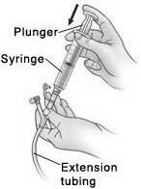

1. Be sure to kink the tubing before removing the cap or disconnecting a syringe to prevent backflow.
2. During feedings, position the person as upright as possible.
3. Leave the person at a 45 degree upright position for at least 30 to 60 minutes after feeding.
4. Provide mouth care to the person.
5. Provide care to the insertion site.
6. Accidental G-tube removal: Ohio DDD med manual

a. If a tube accidentally comes out, the person should be seen immediately as a G-tube tract begins to close within a couple of hours. Call the medical provider for instructions or have the person seen at the emergency department. Cover the stoma with a clean dressing. If this is a recurrent problem, develop a protocol to follow.

## General instructions regarding G-tubes – GRAVITY FEEDINGS:

## The gravity method is a way to send formula from the feeding bag into a feeding tube by the force of gravity. Gravity pulls the formula in a downward direction.

## Clean hands and gather supplies. Needed supplies include:

## The amount of formula prescribed by the healthcare provider.

## A gravity feeding bag

## A cup

## An IV pole or hook for hanging the feeding bag

## A clean cloth or paper towel

## A container of water (tap water at room temperature is ok)

## A 60 ml legacy catheter tip or ENFit syringe

## Tape

## A button adapter, if the person has a button instead of a tube

## 

## 

Button Tube with legacy connector (left)

and ENFit (right)

1. 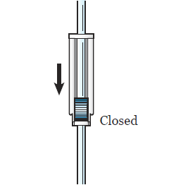Close the roller clamp on the feeding bag. →
2. Wipe the top of the formula can with a clean cloth or paper towel. Pour the prescribed amount into the feeding bag.

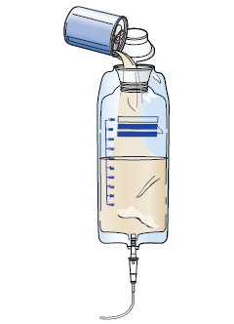a. The bag will hold 1000 mL (4 cans) at a time.

If the feeding is run throughout the day or

night, pour in 6 to 8 hours’ worth per feeding at

a time. For example, if the tube feeding rate is

120 mL per hour, then pour 1 can every two

hours. The bag can be filled with 3 to 4 cans at

a time.

## Hang the feeding bag 2 to 3 feet above the person on either an IV pole or hook. It should be close to a comfortable chair or bed.

## Hold the end of the feeding bag tube over a cup. Remove the cap at the end of the tube.

## Slowly open the roller clamp. This gets the air out of the tubing.

## If the feeding bag tubing does not have a roller clamp, slowly open the cap, and pinch the tubing until the liquid gets to the end.

## 

## Open roller clamp Open plug at end of legacy connector (left)

## and ENFit (right)

## Open the plug at the end of the feeding tube.

## If there is a button, put the adapter into it.

## If using a tube without a clamp, pinch the end of the tube to avoid leakage or put the tube in a cup.

## Fill the syringe with the amount of water recommended by the healthcare provider. Place the syringe into the end of the feeding tube or button adapter.

## Unclamp the feeding tube.

## Flush feeding tube.

## 

## Open the plug at end of legacy connector (left) and ENFit (right)

## Re-clamp feeding tube. Disconnect the syringe.

## Connect the end of the feeding bag tubing to the feeding tube or button adapter. Make sure that the end of the tube is placed firmly. A piece of tape may be placed over the connection to keep it from separating.

## Unclamp feeding tube and slowly open the roller clamp on the feeding bag tubing. Allow the formula to drip in over at least 30 minutes.

## Check the bag every 5 to 10 minutes. If the formula is flowing too fast or too slowly, adjust the roller clamp as needed.

## The bag can also be lowered or raised to change the flow rate.

## When the feeding bag is empty, close the roller clamp on the feeding bag tubing. Close the clamp on the feeding tube. Disconnect the feeding bag and set it aside.

## Fill the syringe with the amount of water recommended by the healthcare provider. Place the syringe into the end of the feeding tube or button adapter. Unclamp and flush the feeding tube.

## Use a new syringe every 24 to 48 hours to prevent infection.

## Clamp the feeding tube, remove the button adapter (f using one), and cap feeding tube.

## When done, rinse the feeding bag. Pull the pieces of the syringe apart and rinse each part with warm water. Let supplies air dry.

## Use a new feeding bag every 24 to 48 hours to prevent infection.

Information and clipart for gravity feeding and MIC-Key information taken from https://www.mskcc.org/cancer-care/patient-education/tube-feeding-using-gravity-method

**How to connect and disconnect the extension set from a MIC-KEY button adaptor**

If the person has a button adaptor, follow these steps to connect and disconnect tubing from the button:

1. Uncap the button (or MIC-KEY feeding port).
2. Place the extension set over the button.
3. Line up the black lines on the extension set and the button and push down firmly.
   * To connect, follow the arrow on the adapter by turning it clockwise (to the right) until it locks in place. Do not turn the connector past the lock place. Keep the extension in this locked position during feeding.
   * To disconnect, follow the arrow on the adapter by turning it counterclockwise (to the left) until the black lines line up. Pull the adapter up.

## General care of insertion site for G-tube and J-tube:

1. Check skin for redness, irritation, or leakage of stomach fluid or contents.
2. Use a gauze or clean cloth to clean skin with mild soap and water using a circular motion, moving outward from the tube to the outer skin areas.
3. Make sure G-tube is not becoming embedded and that it can be rotated

within the stoma (the hole through the skin into the stomach).

## General care of feeding tube (daily):

1. Using gauze or a clean cloth, clean the tube with mild soap and water moving from the tube outward.
2. The bolster: rotate a quarter turn every day to relieve pressure on the skin and allow aeration.
3. An external bolster that is too tight can lead to skin breakdown.
4. Be sure to clean thoroughly under the external bolster with water and a cotton swab daily.

# ORAL SUCTIONING

* There are times that clients have excess secretions in their mouths that they are not able to handle, and which can lead to choking and aspiration. DSPs may perform oral suctioning which is suctioning inside the mouth only. Training to perform this task must be documented.
* DSPs may not perform deep suctioning (suctioning down into the throat) or suction through a tracheostomy tube (a tube in the neck).

# PROCEDURE FOR ORAL SUCTIONING:

1. Place suction machine on a sturdy surface and plug in.

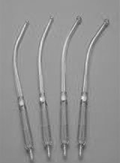

1. Wash hands and put on gloves.
2. Connect tubing to the outlet port on the lid of the collection container.
3. Attach the suction catheter device (called a Yankauer) to the other end of the tubing.
4. Turn on suction machine and check for suction pressure. Follow manufacturer’s instructions for how to check and set for the correct amount of suction

indicated for the individual. Ohio DDD med manual

* + Excessive suction can be dangerous and painful.

1. Insert suction catheter into mouth, placing the tip of device where a toothbrush would go on the lower jaw. Circle the catheter around the bottom of the mouth for 15 seconds.

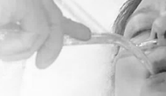

1. Remove catheter, wait 15 seconds, repeat if necessary.
2. If the person start to cough or gag while suctioning, Guardian Angels Training

take the catheter out of the mouth until the person recovers. Then continue.

# NEVER SUCTION FOR LONGER THAN 15 SECONDS.

1. After finishing, suction water through the suction catheter until the catheter and tubing are clear.

## Never allow the fluid in the collection container to rise about the fill limit line.

1. Turn machine off, empty collection container and clean thoroughly before putting away equipment.
2. Document and note any concerns or problems encountered.

# CATHETERS

* 1. All DSPs may perform urinary catheter care including cleaning and care of the catheter and catheter site, clamping the catheter tubing, and emptying the urine collection bag. Training of these procedures must be documented.

# URINARY CATHETER CARE:

## External urinary catheters:

* + 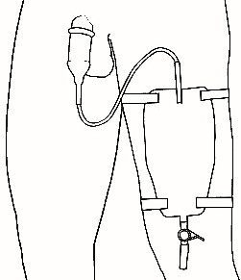These are sometimes called Texas or condom catheters.
  + They are rolled up onto the male penis like a condom have a tube that drains into a bag. The bag is emptied when half full.
  + After the bag is emptied, rinse with cold water and shake

the bag for 10 seconds. Empty water into toilet and

repeat. urotoday.com/library-resources/bladder-health

* + Then using a mixture of 1 part vinegar to 3 parts water, fill the bag with until half full. Let sit for 30 minutes, and empty into the toilet.
  + Rinse the bag with warm water, let dry before using. Change bag daily.
  + There are some made specifically for females that not as easy to use.

## Internal (indwelling) urinary catheters:

* + Must be inserted and removed by a licensed medical professional. These are inserted through the urethral opening or through the abdominal wall.
  + The tubing that exits the body and the exit site must be cared for and cleaned to prevent infection.
  + Anyone with an indwelling catheter should shower, not bathe, as bathing increases the risk for infections. Someone with a suprapubic catheter can often bathe with permission from the medical provider.

## Care of catheter – procedure:

1. Gather equipment and supplies. Wash hands and put on gloves.
2. Identify the person, provide privacy, and explain procedure.
3. Have the person lie back, exposing only a small area where the catheter enters the body. **Be sure the catheter bag always remains lower than the bladder.**
4. Wash the area surrounding where the catheter enters the body with mild soap (such as Dove®) and water.
   * If working with an uncircumcised male, retract the foreskin and cleanse area. Return foreskin to original position.
   * For a suprapubic catheter site, if there is a shield in place, gently wash under the shield with a cotton-tipped applicator. Some place a 4” by 4” sponge around the catheter and under the shield, cutting a slit in the sponge from one side to the center.
5. Wipe the tube, starting at the point where it enters the body and move downward toward the bag. Never wipe from the bag upward.
6. Check for any kinks or coils in the tubing and straighten if found.
7. Clean up any equipment and discard or return to storage area.

## External catheter care tips:

1. 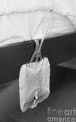Anchor the catheter securely to the person’s upper leg or abdomen using a non-tape binder (catheter tube holder) to prevent pulling.
2. Monitor the catheter system for kinking, obstruction, sediment, leaking, irritation or pulling.
3. Be sure tubing and bag are below level of the bladder when the person is up and about.
4. Hang collecting bag so it does not touch the floor.
5. Report any redness, discharge, or irritation in the catheter area.

# DO NOT:

* + Pull on collecting bag or catheter.
  + Disconnect the catheter tubing. If it accidentally comes apart, wipe the ends with alcohol and reconnect.
  + Place the collecting bag on the bed or raise it above the level of the bladder. It needs to be lower than the person’s bladder to promote drainage from the bladder.

## Steps for emptying the urine collection bag:

1. Gather equipment and supplies. Wash hands and put on gloves.
2. Identify the person, provide privacy, and explain the procedure.
3. Remove the urine bag outlet tube from its holding area and open it over an appropriate container for measuring. Drain contents of the bag, being careful to not splatter urine. Always keep the bag below the level of the person’s bladder.

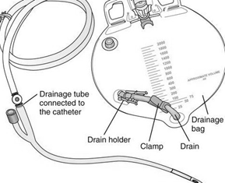

1. Re-clamp the outlet tube to the urine bag. Clean and dry the tip of the outlet tube before putting it back in its holder.
2. Record the amount of urine drained.
3. Report any unusual color or odor, or if the volume is

unusual for that person.

Ohio DDD med manual

# OSTOMIES – COLOSTOMY, ILEOSTOMY, UROSTOMY

* All DSPs may perform ostomy site care including emptying and changing ostomy bags. There must be documentation of adequate training to perform these tasks.
* Surgical procedures may be done to take out a section of bowel, waste products are then rerouted out of the body via a stoma. This is called a colostomy or ileostomy.
* Surgical procedures may also reroute urine to exit the body via a urostomy.

# OSTOMY CARE

## Skin Care:

The skin around the stoma should look the same as everywhere else on the abdomen. The output through the stoma can irritate the skin and make it tender and sore. To help prevent that, follow the guidelines below:

1. Using the right sized pouch is important as an opening that is too small can cut or injure the stoma and may cause it to swell. If the opening is too large, output could cause irritation to the skin.
2. Change the pouch regularly to avoid leaks and skin irritation but don’t change more than once a day unless there is a problem.
3. Be careful when pulling the pouch away from the skin as the skin barrier is sticky and can injure the skin if pulled too fast. It is best to remove the skin barrier by pushing the skin away from the sticky barrier rather than pulling it off.
4. Clean the skin around the stoma with water and dry the skin completely before putting on the skin barrier or pouch. If soap must be used, use one that does not contain lotions as those can cause problems with the barrier sticking well.
5. Watch for sensitivities to the adhesive, skin barrier, paste, tape, or pouch. They can develop at any time. If the skin is irritated where the plastic pouch touches the skin, a pouch cover or different brand of pouch may be needed.

## Emptying a colostomy or ileostomy pouch:

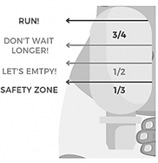

1. When is it time to empty an ostomy bag?
   * Empty the pouch when it is about 1/3 to 1/2 full to keep it from bulging and leaking.
2. Have the client sit on the toilet as far back as possible or sit on a chair facing the toilet.
3. Place a strip of toilet paper in the toilet bowl to decrease splashing.
4. Hold the bottom of the pouch up and open the clip on the end of the pouch.

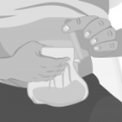

1. Slowly unroll the end of the pouch (also called the tail) over the toilet.
2. Gently empty the contents.
   * Press the sides of the stoma bag opening to widen it.
   * The contents will spill out.
   * With your fingers, you can press the bag to empty any residual contents.
3. After clearing out all the contents, the bag may be rinsed, or wipes may be used to clean any residue.

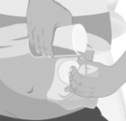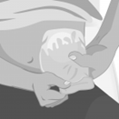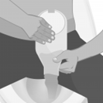

1. Clean the outside and inside of the bag tail with toilet paper.
2. Roll up the tail of the pouch slowly and fasten the Velcro or re-apply the plastic clip.

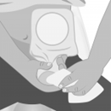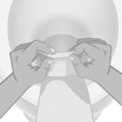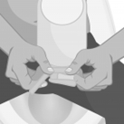

Clipart on this page from [https://farmoderm.it/en/emptying-an-ostomy-ba](https://farmoderm.it/en/emptying-an-ostomy-bag/)g/

## Changing the ostomy bag:

Collect all supplies needed including a new ostomy pouch, barrier supplies, scissors, and supplies needed to clean and dry the skin.

1. Empty the pouch into the toilet before removing. Make sure you have gloves on to do this.
2. Remove the pouch and barrier carefully to avoid pulling the skin. Keep the clip and put the ostomy pouch into a plastic bag and place in the trash.
3. Remove gloves, wash hands, and put on a clean pair of gloves.

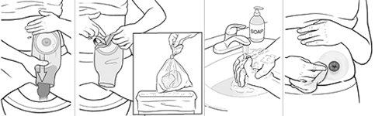

1. Clean the skin around the stoma and dry with a clean towel. Check the skin around the stoma.
   * Spots of blood are normal as cleaning around the stoma when changing the pouch can cause slight bleeding because the blood

vessels in the tissues of the stoma are very delicate at the surface.

* + The skin should be pink or red, not purple, black, or blue. If there is a change in color, notify the medical provider.

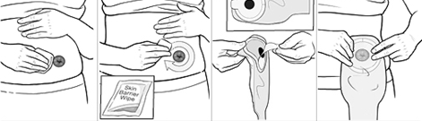

1. Trace the shape of the stoma to the back of the new pouch and barrier or wafer (wafers are part of a 2-piece pouch system) and carefully cut out the shape.
   * Use a stoma guide with different sizes and shapes if available or draw the shape of the stoma onto a piece of paper and cut out. The edges of the opening should be close to the stoma but should not touch the stoma itself. Then use this to trace onto the back of the new pouch or wafer.
2. Use skin barrier powder or paste around the stoma if this has been recommended. Remove the backing from the pouch. Make sure the opening of the new pouch is centered over the stoma.
   * If the stoma is at or below the level of the skin, or if the skin around the stoma is uneven, using paste will give a better seal.
   * Skin around the stoma should be dry, smooth, without wrinkles.
3. Press firmly onto the skin.
4. Hold your hand over the pouch and barrier for about 45 seconds to help it seal better. Sometimes tape is used around the sides to help seal it.
5. Fold bag and secure it.

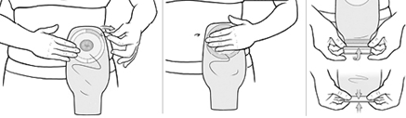

Clipart for changing the ostomy bag obtained from demo.staywellhealthlibrary.com/Content/healthsheets-v1/step-by-step-stoma-care-changing- the-pouch

## When to call the medical provider.

The medical provider or ostomy nurse should be called if the client has:

* + - Cramps that last for more than two to three hours.
    - Continuous nausea and vomiting.
    - No ostomy output for 4 to 6 hours with cramping and nausea.
    - Severe watery discharge lasting for more than 5 to 6 hours.
    - Bad odor lasting longer than a week as this may indicate an infection.
    - Pus draining from the stoma.
    - A cut or injury to the stoma.
    - Bad skin irritation or deep sores around the stoma.
    - A lot of bleeding from the stoma opening.
    - Continuous bleeding where the stoma meets the skin.
    - Any unusual change in stoma size or color.

# ENEMAS:

* 1. Medication certified staff may give enemas after appropriate training.
  2. Enemas require an order from a medical provider.
  3. Training may be done by others including experienced DSPs or group home managers.
  4. Document that training was completed, and proficiency was observed.
  5. Staff may **only** give enemas from a prepackaged kit containing a prefilled dispensing bottle with a soft tip.
     + Staff may not mix enema solutions.
     + Staff may not use an enema kit that contains tubing and a bag that they must fill.

# INSTRUCTIONS FOR GIVING AN ENEMA:

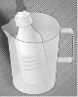

1. Gather supplies: the enema kit, gloves, lubricant, and towels.
2. Warm the enema solution to body temperature by placing in a container of warm water.
3. Lay towels over the place that you will be administering the enema and have other towels within reach.
4. Wash hands and put on gloves.

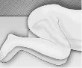

1. Have the person lie on their left side with both knees bent or just the right knee bent. Place a rolled up towel under the right knee for support.
2. Remove the cap from the tip of the enema nozzle – apply lubricant such as K-Y jelly to the person’s anus to make insertion easier and onto the enema nozzle if not pre-lubricated.
3. Gently insert the tip of the enema nozzle into the rectum slowly with a slight side to side motion, the tip pointing towards the navel. The enema tip is generally about 3 inches long. Do not force the tip into the anus as this may cause

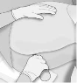

injury. Insertion should not be painful.

1. After insertion, slowly squeeze the enema container to push the liquid into the rectum. Squeeze from the bottom to empty the container.
2. Monitor for cramping. If signs of cramping occur (such as muscle tension in the abdomen), temporarily stop the flow of the fluid.
3. After the bottle is nearly empty, slowly withdraw the nozzle.
4. Have the person remain in that position and try to retain the enema for the recommended time listed on the box
5. Call a healthcare provider:
   * If there is no liquid exiting the rectum within 30 minutes.
   * If there is significant bleeding (more than a few drops of blood).
   * If there is significant pain during the procedure or ongoing cramping or a fever.

Clipart under Instructions for giving an enema from: [semanticscholar.org/paper/How-to-administer-an-enem](https://www.semanticscholar.org/paper/How-to-administer-an-enema)a

# DIABETES CARE:

* 1. DSPs are expected to perform blood glucose testing as ordered by the medical provider.
  2. Training of how to perform glucose testing may be done by other DSPs or group home managers. There must be documentation that training was completed, and that the person showed adequate proficiency.
  3. Protocols must be in place to direct staff when to check glucose levels, what to do with the results of glucose testing, and how to respond to abnormal test results.
  4. DSPs **may not** administer insulin (ARM 37.34.113 Health and Medication Administration Manual).
  5. DSPs **may not:**
     + calculate insulin doses
     + draw up insulin
     + manage an insulin pump
  6. Insulin must be handled by licensed nurses.
     + Note: EMTs, pharmacy techs, and pharmacists may not administer insulin.

# USING A GLUCOSE TESTING DEVICE (GLUCOMETER):

* Follow instruction provided by the manufacturer for proper use and care of the glucometer and lancets used by the individual.
* The glucometer and lancet pen (if used) can only be used by the individual for whom it was purchased (not by other clients).

# SAMPLE COLLECTION:

1. Be sure to apply the lancet to the side of the finger, not the fingertip pad as the pad is more sensitive.

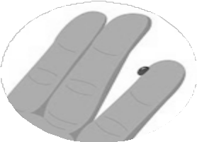

1. Rotate finger sites to avoid callus formation.
2. The presence of any redness, bruising, or callus requires using a different site.
3. There are alternate sites that can be used but they are not as accurate. Only use alternative sites at the direction of the medical provider.

news.medical.net

# PROCEDURE FOR TESTING BLOOD GLUCOSE LEVELS:

1. Gather equipment, supplies. Wash hands, put on gloves.
2. Have the person wash hands.
3. 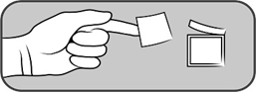Cleanse area to be pricked with an alcohol pad. Be sure finger is dry before using lancet.
4. Place lancet in pen (if lancet pen is used). Lancets may never be used more than once.
5. Turn glucometer on, insert strip (if used in this glucometer).
6. Puncture the side of the finger with the lancet.
7. 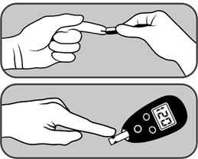Point finger downward and gently massage to get an adequate sample.
8. If it is difficult to obtain a good drop

of blood from the fingertip:

* + Rinse fingers with warm water, then shake the hand below the waist.
  + Gently squeeze or “milk” the fingertip.

1. Gather the blood onto the strip.
2. Using a gauze pad or cotton ball, wipe

finger and hold in place until bleeding stops.

1. Read and record the blood sugar level on the appropriate form.
   * Follow any parameters in place for notifying the appropriate healthcare professional for low or high readings.
   * Follow protocol steps for treating low or high blood sugar levels.
2. Clean equipment, store supplies and dispose of used lancet and gloves.
3. Wash hands.

Clipart on this page from *clipart.me/free-vector/blood-sugar-test*