STATE OF MONTANA
NATIONAL INTEREST WAIVER (NIW)
PUBLIC INTEREST LETTER
APPLICATION

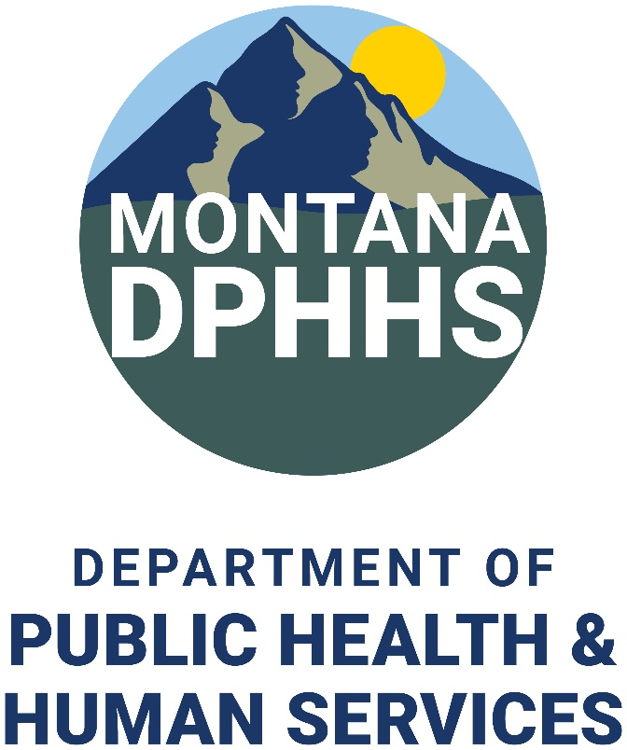

Montana Primary Care Office
Family and Community Health Bureau
1625 11th Avenue
PO Box 4210
Helena, MT 59620-4210

MontanaPCO@mt.gov
(406) 444-3934
NATIONAL INTEREST WAIVER (NIW) PUBLIC INTEREST LETTER

Program Overview

Foreign physicians that have worked for two years in a designated underserved area with a J-1 visa waiver may apply for a National Interest Waiver (NIW) to extend their stay while working in a designated health professional shortage area in Montana. The Montana Department of Public Health and Human Services (DPHHS), Montana Primary Care Office (PCO), is the designated state health department agency to provide NIW public interest letters of support. NIW applicants must meet the following criteria:

- The physician must agree to provide services full-time, at least forty (40) hours per week, in a designated underserved area for at least five (5) years in a clinical practice.
- The physician must serve in a primary care setting (general practitioner, family practice, general internist, pediatrician, obstetrician/gynecologist, or psychiatrist), or be a specialty physician.
- The physician must serve in a Health Professional Shortage Area (HPSA), Mental Health Professional Shortage Area (MHPSA), or a Medically Underserved Area (MUA).
- The physician must obtain a letter from the state department of health, that has knowledge of your qualifications as a physician, that states your work is in the public interest. This statement is known as an attestation or public interest letter of support.

NIW public interest letter applications may be filed before the completion of the J-1 visa waiver, but the total time of employment under the NIW must be at least five years. There is no limit on the number of NIW applicants the Montana PCO may support in a year.

Montana NIW Application Process

Applications for an NIW public interest letter must be submitted by a physician, or their legal counsel, with evidence of support from the physician’s employer. The application must show the physician’s employer is in a HPSA, MHPSA, or MUA. Complete applications are considered based on the medical need of the community, the healthcare facility’s letter of support, and compliance with the physician’s J-1 visa waiver program.

Submission of a complete application does not guarantee that an NIW public interest letter will be provided. The Montana PCO reserves the right to support or decline these requests. A foreign physician seeking permanent residency should refer to the U.S. Citizenship and Immigration Status (USCIS) policy on NIW, section B, for additional information and program requirements: https://www.uscis.gov/policy-manual/volume-6-part-f-chapter-6. The Montana PCO cannot provide legal advice to physicians, their representatives, or employers.

Application Requirements

- Montana NIW Public Interest Letter Application
- Physician Statement of Commitment to Comply
- Employer Letter of Support
- Employer Statement must be on official letterhead and clearly outline how the physician’s qualifications and future responsibilities will help satisfy the areas shortage and improve access to care, and how a denial of the NIW will negatively impact the community.
- Fully Executed Employment Contract
- Include all appendices. Contract must show the employment is full-time, no less than 40 hours per week, and the employment term is no less than five (5) years in duration. The position and employment location must be specified.
- Current Curriculum Vitae
- Copy of Montana Medical License

Please submit complete applications to the Montana PCO by email to MontanaPCO@mt.gov. Mailed applications can be sent, unbound with no staples or brads, to the following address:

Montana Primary Care Office
Family and Community Health Bureau
1625 11th Avenue
PO Box 4210
Helena, MT 59620-4210

Semi-annual Reporting Requirements

The physician and the employer, Chief Executive Officer or Administrator, must provide employment verification every six (6) months through completion of the five (5) year commitment.

Failure to submit accurate and truthful employment verification reports will delay confirmation of the physician’s service obligation, or credit toward the National Interest Waiver lawful permanent resident status (i.e. Green Card). The Montana PCO is required to comply with federal reporting requirements, the Department of State, and USICS.

Please direct any questions to the Montana PCO by email to MontanaPCO@mt.gov, or call (406) 444-3934.

Montana NIW Public Interest Letter Application

Physician Name:
Residence Address:
City, State, Zip: MT County:
Phone Number: Pronouns/Gender:
Email Address: Date of Birth:
Birth Country: Citizenship Country:
DOS Case Number: NPI Number:
MT Medical License: Discipline/Specialty:

Graduate School:
Degree: Dates Attended:
City, State/Country:

Residency Program:
Degree/Specialty: Dates Attended
City, State/Country:

Sponsoring Facility:
Facility Point of Contact: Contact Email:
Contact Phone: Contact Fax:
Facility Address:
City, State, Zip: MT County:
Employment Start Date: HPSA ID#:
Physician Signature: Date:

Printed Name:

Statement of Commitment to Comply with Program Requirements

It is understood that the purpose of the Montana Department of Public Health and Human Services (DPHHS) support for a National Interest Waiver (NIW) program is to increase access to healthcare in designated health professional shortage areas. I agree that I will provide such services in exchange for the Montana Primary Care Office (PCO) to provide an NIW public interest letter of support on my behalf. I agree to comply with all NIW program requirements including:
- Agree to a five-year commitment to serve full-time (at least 40 hours a week) at the healthcare facility named in the waiver application OR continuing to fulfill the required period of clinical medical practice in Montana for an aggregate total of 5 years
- Agree to work in a designated Health Professional Shortage Area (HPSA), Mental Health Professional Shortage Areas (MHPSA), or Medically Underserved Area (MUA)
- Seek approval from the Montana PCO prior to changing practice location or scope
- Notify the Montana PCO of any change to my mailing address, email, or phone number
- Submit a copy of the USCIS approval notice to the Montana PCO
- Cooperate with site visits and other program monitoring activities
- Submit semi-annual employment verification reports to the Montana PCO
- Complete periodic retention surveys

Signature Date

Printed Name

