*Pertussis Testing Recommendations:*

Testing is the best way to distinguish between pertussis and some other cough illness. The best way to test for pertussis is using a PCR test. This test is widely available at healthcare sites and is also available at the Montana Public Health Laboratory in Helena, MT. Early testing leads to early treatment, improved outcomes, and reduced community spread.

The PCR Pertussis test works best when used during the first three weeks of the cough illness. Those without a cough or who have completed antibiotic treatment for pertussis should not be tested.

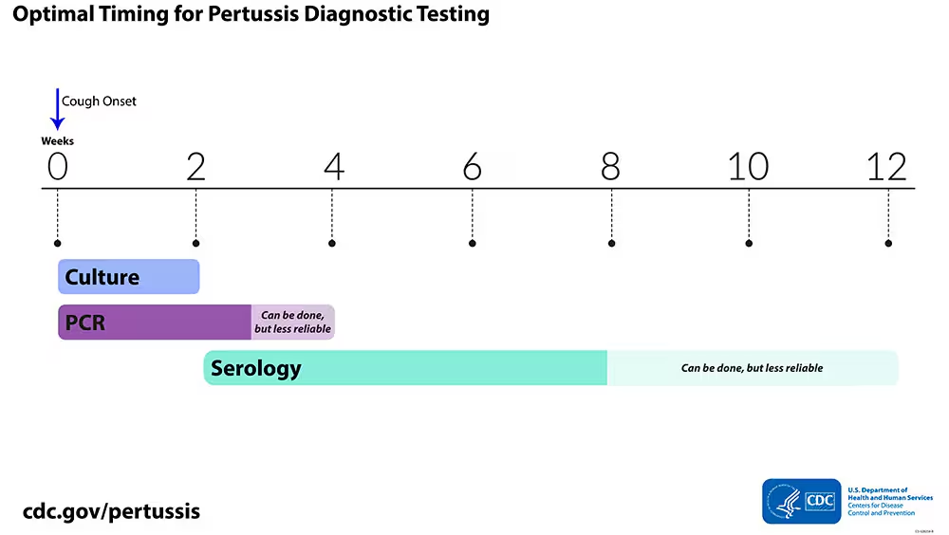

Pertussis testing does NOT need to be confirmed at the Montana Public Health Laboratory in Helena.

Pertussis testing at Montana Public Health Laboratory

Test: Bordetella pertussis/B. parapertussis/B. holmesii Direct Detection by Real Time PCR

Online Order Name/Abbreviation: Bordetella spp. Multiplex PCR/Bord Multi PCR

Specimen Requirements: Nasopharyngeal (NP) swab in a sterile container without transport media. Do not submit a throat or nares specimen or a specimen submitted in Regan Lowe Media.

Testing Collection and Transport instructions.

Turn-around Time: One to two working days. Positive results are telephoned to the submitter.

NOTE: PCR testing should be performed only on symptomatic patients; a positive PCR in an asymptomatic patient does not meet the CDC public health surveillance case definition and is not considered a case of pertussis. PCR testing may be able to detect B. pertussis three to four weeks post onset.

Transport Temperature: Ambient or 2-8°C

CPT Code: 87801

Cost: $107.00