Exclusion information for Food Handlers with Salmonella – from the Food Code: <https://www.fda.gov/downloads/Food/GuidanceRegulation/RetailFoodProtection/FoodCode/UCM374510.pdf>

**From page 35**

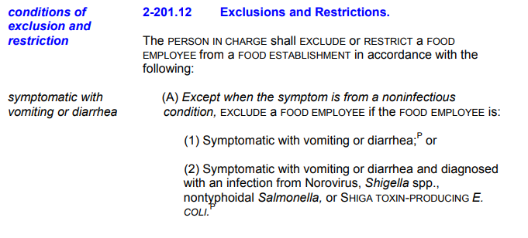

**From page 42:**

