# Logo for the Montana Cardiovascular Health Learning Collaborative - swirling black and red hands shaking under a red heart with the words "The Heart of Healthy Communities" at the top and bottom of the picture.The Heart of Healthy Communities Toolkit:

## Recognizing Local Assets & Fostering Connections for Cardiovascular Health Across Montana

Contents

The Purpose of This Toolkit 2

A Little Background Information 2

Montana’s Many Health Cultures 3

Considerations 4

Where to Focus Your Efforts 5

Identifying and Connecting with Community Resources 5

From the Healthcare System Out 5

From the Community Inward 6

Tools and Data Sources for Understanding, Organizing, and Connecting Community Assets 6

What About Communities with Limited Resources? 8

Tools for Collective Impact 9

Bringing It All Together: Resource Guides 10

Planning and Hosting a Building Community Health Partners Event 12

What Journey Will You Take with This Toolkit? 14

Acknowledgements 14

Thank you! 14

## A graphic: an outline of Montana with a stylized heart and a toolkit inside the outline.The Purpose of This Toolkit

Heart and blood vessel health (called cardiovascular health) is very important for everyone in Montana. In 2021, about **3 out of 10 Montanans (31%) had high blood pressure** and about the same number had **high cholesterol**. Both can cause serious illness, lower quality of life, and shorter lifespans. Most people think lowering blood pressure and cholesterol is something that only doctors can help them manage.

But health is about more than just visits to the doctor. Our health is closely connected to our **friends, neighbors, and communities**. Strong social ties and healthy communities can make a big difference for everyone. Some Montana towns may look like they have many resources, while others may seem to have very few. But the truth is: **every community has strengths** that can help people live healthier lives. It doesn’t matter if your town is small or doesn’t seem wealthy – there are always things that can be done. Like in the story of **“**[**Stone Soup**](https://www.allrecipes.com/article/what-is-stone-soup/)**,”** when everyone contributes, the community creates something greater together.

This toolkit is here to remind Montanans that we already have **resources, talents, creativity, and power** to solve health challenges for both individuals and whole communities. We hope it inspires you to make changes that improve **heart health** and strengthen the **heart of your community**.

### A Little Background Information

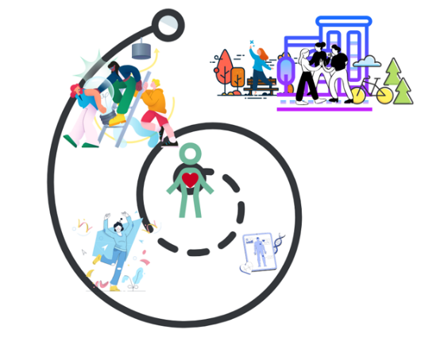In 2023, a survey of Montana’s rural and frontier communities[1] showed that people feel their **community is very important to their health and quality of life**. Those who felt more connected to their communities also reported feeling healthier and happier. Things that support both heart health and overall well-being include:

* Walkable neighborhoods
* Safe, good-quality housing
* Green spaces like parks
* Opportunities to volunteer
* Access to the arts
* Ways for older and younger people to connect and work together

Another important idea is that **every community has assets** – things that can be discovered and used to solve local problems. This is called **“asset-based community development” (ABCD)**. You’ll learn more about it in this toolkit.

This toolkit will help you with:

* Finding and connecting to health-supporting resources in your community
* Using tools, data, and activities that focus on strengths instead of problems
* Figuring out what to do if your community seems to have limited resources
* Creating a community resource guide and hosting an event that builds connection and supports health

There are many tools here—from both national and local organizations. This toolkit is not meant to be unchangeable or “set in stone.” Instead, it’s designed to be adapted. As you discover what works in your community, you can **add, change, or update it**. That flexibility is key to building healthy communities.

The resources gathered here will help communities of all sizes **work together, share ideas, and improve health**—from the heart outward.

## Montana’s Many Health Cultures

When working to improve health, it’s important to remember that every community is made up of many different people and cultures. Communities include:

* People with different abilities and disabilities
* Veterans who have served in the military
* People who may not usually be part of decision-making
* People of different cultural and racial backgrounds

Health can mean different things to different people. Listening to all voices helps make sure solutions work for everyone.

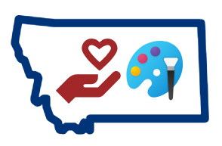Communities also organize themselves in many ways—through businesses, volunteering, faith groups, political groups, or cultural traditions. These are called [**community sectors**](https://ctb.ku.edu/en/table-of-contents/analyze/where-to-start/community-sectors/main), and they are all valuable assets. People in these groups may already be helping to create healthier communities. Examples of community sectors:

Examples:

* **Artists and arts organizations** – Help people [connect socially and support health](https://www.arts.gov/stories/magazine/2023/2/arts-and-health-role-arts-sector-promoting-resilience-and-well-being).
* [**Public libraries**](https://www.thenationshealth.org/content/48/8/1.2) – Provide spaces for learning, gathering, and finding health information.
* **Schools, including Tribal and community colleges** – Provide [health](https://montanapbs.montana.edu/extension/health/documents/school%20based%20Health%20Initiative.pdf) and [nutrition](https://opi.mt.gov/Leadership/Management-Operations/School-Nutrition) support, especially in rural areas.
* **Local leaders** – Can push for healthy policies, like [making neighborhoods more walkable](https://www.saferoutespartnership.org/resources), creating parks, and making it easier to find healthy foods.
* **Non-profits** – Support families, elders, youth, housing, food, and transportation. Your region probably has a [Community Action Agency](https://montanacommunityaction.com/) that has many of these resources.
* [**Local community foundations**](https://mtcf.org/impact/local-community-foundations) – Provide funding, connections, and ideas.
* **Montana State University (MSU) Extension Agents** – Offer resources on [nutrition](https://www.montana.edu/extension/nutrition/), [wellness](https://www.montana.edu/extension/wellness/), and [walkable neighborhoods](https://www.centerfornutrition.org/built-environments).
  + Extension has a [2019 report](https://www.montana.edu/extension/wellness/needs_assessment/index.html) that could be helpful for deciding what projects a community might want to focus on.

### Considerations

The [Collective Power Framework](https://innonet.org/news-insights/resources/collective-power-framework-and-indicators/) can help you make sure you’re including everyone who should be invited.

American Indian Montanans have unique health cultures and values that need to be considered and honored. Resources:

* The [American Indian Governance and Policy Institute](https://www.umt.edu/american-indian-governance-policy-institute/default.php)’s “[key social factors influencing American Indian and Alaska Native health in Indian Country](https://www.umt.edu/american-indian-governance-policy-institute/socioeconomic-factors.php)”
* The “[Caring for Indigenous Montanans](https://healthinfo.montana.edu/cfim/index.html)” learning series from MSU

People transitioning out of the armed forces can find it hard to get reconnected to their community resources and activities. Resources:

* [Total Military Insight](https://totalmilitaryinsight.com/community-engagement-for-veterans/)
* [Soldier On](https://www.wesoldieron.org/wellness-program)

[Universal Design](https://universaldesign.org/definition) principles help you make sure your meetings and projects are accessible and useful for everyone. Universal Design focuses on being tolerant with mistakes, providing enough space for the event or experience planned, and making sure everyone is safe and comfortable. Resources:

* [Seven Principles of Universal Design](https://universaldesign.ie/about-universal-design/the-7-principles)
* [A Planning Guide for Making Temporary Events Accessible to People with Disabilities](https://adata.org/guide/planning-guide-making-temporary-events-accessible-people-disabilities)

### Where to Focus Your Efforts

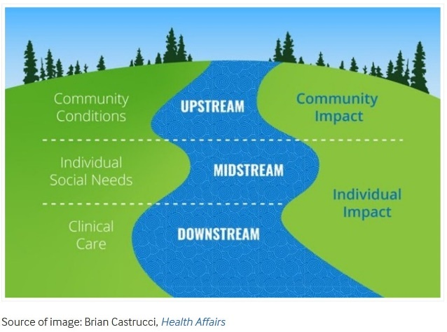Health efforts can happen at three levels:

* Downstream – Treating illness after it happens
* Midstream – Organizations working together to address Social Determinants of Health (SDOH)
* Upstream – Addressing the broader conditions (jobs, housing, education, environment) through policy changes

Communities can strengthen health by:

* Focusing on prevention
* Identifying and addressing SDOH
* Partnering with local organizations
* Involving policymakers

Resources about SDOH:

* [Montana Department of Public Health and Human Services SDOH Program](https://dphhs.mt.gov/publichealth/chronicdisease/SDOH/index)
* [RHI Hub’s SDOH for Rural People](https://www.ruralhealthinfo.org/topics/social-determinants-of-health)
* The [Build Healthy Places Network Resource Library](https://www.buildhealthyplaces.org/tools-resources/network-resource-library/)

## Identifying and Connecting with Community Resources

### From the Healthcare System Out

Healthcare providers are important partners in helping communities get healthy. They can improve the way they help patients by using team-based care:

* Patients are partners in their care
* Providers use their full skills
* Teams include both medical and non-medical staff

Helpful resources:

* [Team-Based Care YouTube Series](https://www.youtube.com/playlist?list=PLOZjFk4ccVk5CgOFHAyeXNbYG0aPshd5q)[2]
* "[Working Beyond the Clinic](https://www.youtube.com/watch?v=U9_b5QdDJkw&list=PLOZjFk4ccVk5CgOFHAyeXNbYG0aPshd5q&index=8)” video
* [American Heart Association Toolkit](https://www.heart.org/en/professional/million-hearts/resources-and-messaging/million-hearts-collaboration-community-clinical-linkages-toolkit)
* [American Hospital Association Infographic](https://sponsors.aha.org/rs/710-ZLL-651/images/comm-collaboration-infographic-FINAL.pdf?version=0) (opens as a pdf)

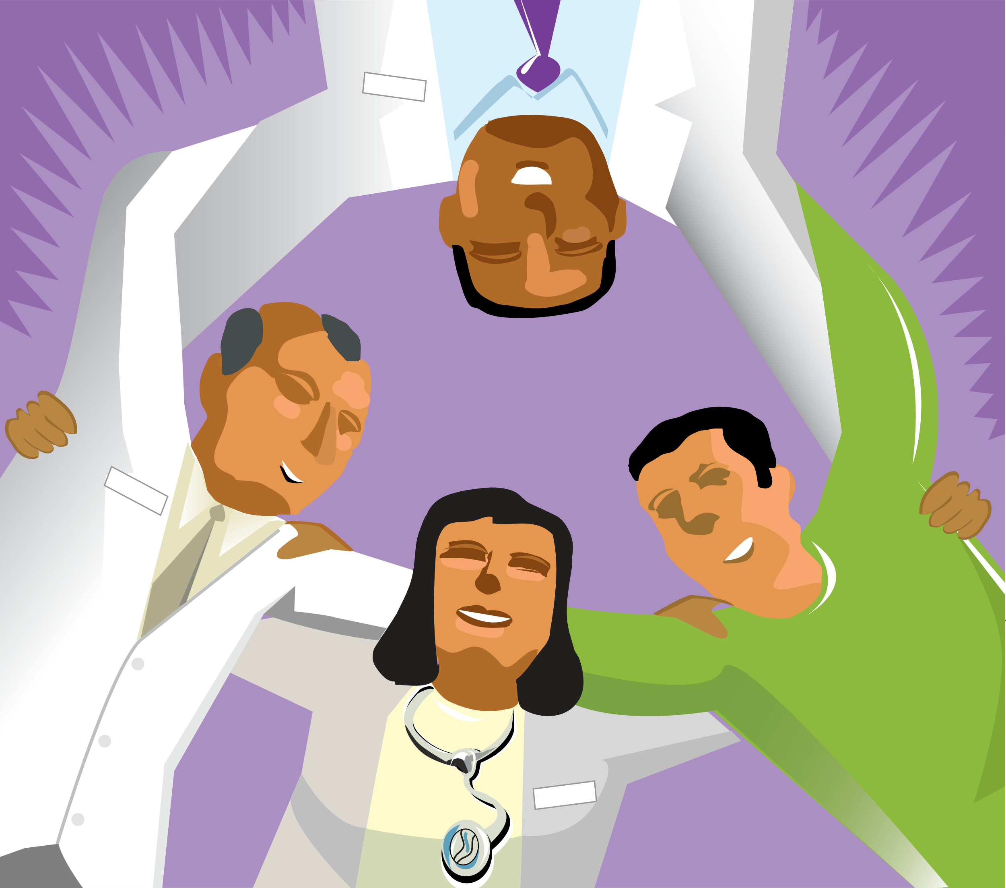

Part of building a healthcare team involves working with community organizations to help educate people about health and find ways to help people access health care outside of a hospital or clinic to prevent and manage diseases.

### From the Community Inward

Community members can also reach out to healthcare organizations to create connections. Some examples:

* Faith organizations – Can host [parish nurses](https://www.fcninternational.org/FCN-Organizations), community meals, and health programs. [Hospital chaplains](https://www.tandfonline.com/doi/full/10.1080/08854726.2024.2401742) may serve hospitals and their community.
* [Community Health Workers](https://www.cdc.gov/chronic-disease/php/community-health-worker-resources/index.html) (CHWs, [also known as](https://chwtraining.org/15-community-health-worker-job-titles-and-different-roles/) Community Health Representatives, Promotoras, Peer Support, Health Educators, Patient Navigators, etc.) – Trusted community members who connect people to services. CHWs in Montana are supported by:
* The [Montana CHW Association](https://mtchw.org/about/definition/)
* [Montana State University](https://healthinfo.montana.edu/chw/index.html)
* The [University of Montana](https://www.umt.edu/ccfwd/training/communityhealth/)
* [Community Paramedicine](https://www.ruralhealthinfo.org/topics/community-paramedicine) (also known as Community Integrated Health) – Lets paramedics and emergency medical technicians provide some public health and primary care services to improve healthcare access.

### Tools and Data Sources for Understanding, Organizing, and Connecting Community Assets

#### An image showing an example of a community asset map. It has the gifts of individuals at the center. This is connected to citizens associations, local institutions, schools, youth, artists, "labeled people" (in this case, people with disabilities), community colleges, cultural institutions, older adults, hospitals, parks, income, houses of worship, and business. These are just some examples of community assets, and they are all interconnected in some way. Lines are crawn throughout the image, connecting the community assets.Community Mapping Tools and Data Sources

* [Building Healthy Places Network Mapping Tools](https://buildhealthyplaces.org/tools-resources/measure-up/mapping-tools/): A collection of mapping tools. Many let you create your own maps.
* [County Health Rankings and Roadmaps](https://www.countyhealthrankings.org/health-data): Lets you find and compare counties like yours based on information you think is most important.
* [Congressional District Health Dashboard](https://www.congressionaldistricthealthdashboard.org/): Includes 40 measures for all 435 U.S. Congressional Districts
* [DPHHS Data Dashboards](https://dphhs.mt.gov/interactivedashboards/): Interactive ways to view Montana-specific data about many different health topics.
* [CDC PLACES](https://www.cdc.gov/places/index.html): Provides local health and health-related data for many different types of places (counties, census tracts, zip codes) across the country.
* [Center for Applied Research and Engagement Systems (CARES) HQ](https://careshq.org/): From the University of Missouri Extension Service. Uses data and tools to support better informed decision making.
* [Maptive Community Asset Mapping](https://www.maptive.com/community-asset-mapping/): Can support the community asset mapping process, but the tool is not free.
* Montana Healthcare Foundation’s list of [Montana Community Health Assessments](https://mthf.org/resource/community-health-assessments/) and the [Montana Local (Health-Related) Plans Database](https://chronicdiseasedata.org/Dashboard). Done every three to five years, these assessments help county health departments and local hospitals plan the most important work they can do to improve community health.
* [Open Street Map](https://www.openstreetmap.org/#map=5/38.01/-95.84): Allows local people to create their own accurate maps of what they think is important to the health of their community.

#### Food Access and Food Systems-Related Resources

* [Abundant Montana Find Food and Farms Map](https://abundantmontana.com/search/): Brings Montana food and farm access information all to one place.
* [Central Texas Food System Dashboard](https://www.centraltxfoodsystem.org/food-access#nutrition): Offers a good way to see all the important parts of a local food system to consider when thinking about assets.
* [Colorado Food System Map](https://foodsystems.colostate.edu/co-foodsystems-map/): Makes state and national food-related data more accessible to answer questions and guide decision-making.
* [FNDI Food Sovereignty Assessment Toolkit](https://www.firstnations.org/publications/food-sovereignty-assessment-tool-2nd-edition/): From the First Nations Development Institute, this tool helps Native communities reclaim their local food systems and assess food access, land use, and food policy in their communities.
  + [FAST's Community Food Security and Food Sovereignty Assessment](https://static1.squarespace.com/static/6276a3e91103106ef0b1eab0/t/67ca032274cd1307bd376258/1741292337211/FASTBlackfeet_CommFoodAssess_v02.pdf) was done using this tool.
* [Nutrition Environment Measures Survey (NEMS)](https://nems-upenn.org/tools/): Measures focus on the availability of healthy choices, prices, and quality.
* [Reimagining Native Food Economies](https://nativeamericanagriculturefund.org/wp-content/uploads/2020/10/NAAF_NativeFoodEcon_Spread.pdf): Opens as a pdf and provides a vision for building and recovering Native food systems.

#### Skill-Building Toolkits

No matter how small or large your organization or community is, you can find useful tools in the following lists of resources:

* [Asset Based Community Development (ABCD)](https://en.wikipedia.org/wiki/Asset-based_community_development) from the [Asset Based Community Development Institute](https://abcdinstitute.org/content.aspx?page_id=22&club_id=104994&module_id=683173) was developed to help communities use a strengths/assets focus for community improvement. ABCD involves assessing resources, skills, and experience in a community; organizing around issues that inspire people to act; and determining and taking appropriate action.
* The [Community Tool Box](https://ctb.ku.edu/en) from Kansas University has a lot of easy-to-search resources to help you think about, plan, and act on community building projects from start to finish.
* Healthy Places by Design’s [Essential Resources for Socially Connected Communities](https://healthyplacesbydesign.org/essential-resources-for-socially-connected-communities/) includes resource guides, webinar recordings and slides, articles, and other accessible information.
* [Liberating Structures](https://www.liberatingstructures.com/) shares 32 interesting ways hold meetings to identify problems and solutions, come up with creative ideas, and energize people around change-making.
* Visible Network Labs’ [community engagement toolkit](https://visiblenetworklabs.com/2025/04/01/community-engagement-tools-for-building-connected-communities) and ["101" guide for community engagement](https://visiblenetworklabs.com/guides/community-engagement-101/) offer ways to understand who has power, connections, and voice in your community and how to use that information to help make your work together more successful.

#### Techniques for Asset and Community Building

* Asset Mapping: It’s possible to focus on what the community has, rather than on what it does not. Assets and strengths can be used to meet community needs and improve community life. Asset mapping helps identify those strengths. Here are two resources:
  + [Asset Mapping – Kansas University Community Toolbox](https://ctb.ku.edu/en/table-of-contents/assessment/assessing-community-needs-and-resources/identify-community-assets/main)
  + [Georgia Health Policy Center's Toolkit for Community Assessment: Community Asset Mapping](https://ruralhealthlink.org/wp-content/uploads/2021/11/C4-Toolkit-Community-Asset-Mapping.pdf) (downloads as pdf)
* 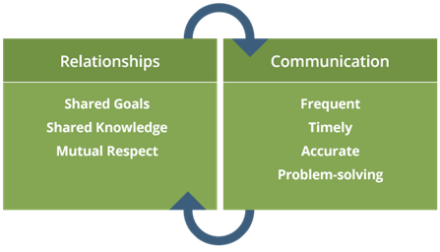Relational Coordination (RC): RC helps us understand how people on teams communicate with each other and how trusting and good their relationships, so we can focus on how to improve both important parts of working together well. Here are two RC resources:
  + [Relational Coordination Mapping from Liberating Structures](https://www.liberatingstructures.com/relational-coordination/)
  + [Relational Coordination Collaborative from Brandeis University's Heller School for Social Policy and Management](https://heller.brandeis.edu/relational-coordination/about-rc/index.html)
* [Power Mapping](https://www.saferoutespartnership.org/sites/default/files/resource_files/Power%20Mapping%20101%20How%20Communities%20Can%20Make%20Connections%20and%20Improve%20Park%20Access%20-%20FINAL.pdf) can help a community figure out who has more and less power to make decisions and create positive changes and how to work with that knowledge.
* [Social Network Webbing](https://www.liberatingstructures.com/23-social-network-webbing/) can help a group see hidden resources in their existing networks and relationships and figure out ways to tap into those assets.
* Social Network Analysis from [Visible Network Labs](https://visiblenetworklabs.com/guides/social-network-analysis-101/) can help a community visualize local relationships organizations and individuals.
* [World Cafe](https://theworldcafe.com/key-concepts-resources/world-cafe-method/) helps large groups have small conversations that move them toward specific, larger goals.

## What About Communities with Limited Resources?

Even communities with few resources have strengths to build on. A couple of places to get started are:

* The Rural Health Information (RHI) Hub’s [Tools for Success](https://www.ruralhealthinfo.org/success)
* The “[Five Steps For Implementing ABCD in Rural Communities](https://www.tamarackcommunity.ca/articles/five-steps-for-implementing-abcd-in-rural-communities)” by the Tamarack Institute
* The Building Health Places Network’s [Rural Resources](https://buildhealthyplaces.org/tools-resources/rural-resources/) page

For healthcare:

* Refer to [Montana 211](https://montana211.org/about) or [RHI](https://www.ruralhealthinfo.org/) for ideas and resources.
* Practice [team-based care](https://www.acponline.org/practice-career/patient-and-interprofessional-education/team-based-care-toolkit)
* Expand access with telehealth, group education, or self-management tools ([AMA Digital Health Hub](https://edhub.ama-assn.org/collections/46498/digital-health)).
* Use referral tools like [Connect Montana](https://connectmontana.org/) (free to use).
* The ECHO Model® – A virtual learning network for providers in small communities. Examples:
* [NM ECHO](https://iecho.org/home)
* [Indian Country ECHO](https://www.indiancountryecho.org/)
* [Billings Clinic ECHO](https://www.billingsclinic.com/medical-professionals-billingsclinicconnect/project-echo/)

### An image showing a continuum of collaboration from disorder and confusion (many curved arrows going in many different and conflicting directions) to individual impact in isolation (many straight arrows going in many different directions) to coordinated impact with alignment (many straight arrows all going in the same direction but at different paces) and collective impact with collaborative action (many straight arrows lined up end to end and supporting each other toward a shared goal).Tools for Collective Impact

[Collective Impact](https://collectiveimpactforum.org/) is a way for community members and organizations to learn together and find ways to act together to make community improvements that everyone can agree on. Collective Impact is useful when there’s a really hard, or “[wicked](https://commonslibrary.org/what-are-wicked-problems/),” problem that needs to be fixed.

#### Tool #1: The Collective Impact Model

Five key conditions:

* *Common Agenda* – Shared vision for change
* *Shared Measurement System* – Track progress together
* *Mutually Reinforcing Activities* – Each group contributes in its own way
* *Continuous Communication* – Regular, open, and honest dialogue
* *Backbone Support Organization* – A team that supports all the other efforts

#### Tool #2: Community Heart & Soul Program (Orton Family Foundation)

The [Community Heart & Soul](https://www.communityheartandsoul.org/) method helps communities identify values and include voices that are often left out. The Montana Community Foundation and MSU Extension Service are using this method around Montana.

Community Heart & Soul has helped Tribal and rural communities in Montana:

* Build trust across generations and cultures
* Bring together fragmented work
* Create action-oriented community plans based on shared values

#### Tool #3: Food Sovereignty Assessment Program, First Nations Development Institute

[This tool](https://www.firstnations.org/publications/food-sovereignty-assessment-tool-2nd-edition/) helps Tribal and non-Tribal communities strengthen local food systems. With this model, communities can:

* Map their local food supply chains
* Rebuild farming and distribution infrastructure
* Support youth and elder knowledge transfer
* Establish working food councils or community co-ops

#### Suggested Steps to Begin Collective Action

1. Start With Listening
2. Define the Common Goal
3. Build the Team
4. Assess Your Starting Point
5. Design and Launch Actions
6. Measure and Share Progress

## An image depicting some of the categories that might be included in a community resource guide: a diploma (education), food, financial needs, housing, transportation, and clothing. The words "Community Resource Guide" are in the center of these images. Bringing It All Together: Resource Guides

#### Four-step process (A3c)

* **A**ssess what’s already out there.
  + Does your community already have a guide? Ask around at hospitals, clinics, chambers of commerce, local non-profits, libraries, community foundations, houses of worship, and schools to see if one or more versions of a resource guide exist.
    - If they do, ask for a copy. Ask to talk with the person/group that maintains it. Ask when it was last updated. Ask if the creator(s) need help maintaining it.
    - If they don’t, keep searching. The Montana Judicial Branch updates [resource lists for each Montana county](https://courts.mt.gov/SelfHelp/Resources/CountyResourceGuides) for judicial system-involved people each year. These guides might be what you’re looking for. [Montana 2-1-1](https://montana211.org/about) also offers a good database of local resources
* **C**omplement/**C**oordinate with existing efforts
  + Ask around to find out if there are already community groups, coalitions, ad hoc committees, or other networks that meet regularly to talk about specific or general resources.
    - If they exist, ask if you can talk with them about what they regularly share with each other (resources, collaborations, etc.) and whether they have an existing resource list. Ask if they talk with other networks and coalitions and the details they’re willing to share about those interactions.
  + If they don’t exist, you might have stumbled on an information vacuum! This is your big chance!
* **C**reate a guide if none exists
  + If there’s an information vacuum (either a lack of resource guide or a lack of a way to share widely)
    - Decide which resources you want to highlight.
    - Decide format(s) that will work best for your community. Asking relevant community members what they need and will use is a good start.
    - Keep the info simple - especially, don’t put a contact name, since these change a lot.
    - Gather, format, and broadcast to preferred community forums.
* Asking people where they get their info and how they’d like to consume the info is a good idea.

#### Action items

* Create a resource guide for a specific “community” that’s defined by those creating it (i.e., a geographically defined community, a community that works together on a specific topic, a community of interest, etc.).
* Involve the members of the “community” in planning and making the resource guide. Ask what resources are most helpful to them and what resources they need.
* Consider including non-traditional resources. Rural communities may have fewer “obvious” health support resources and non-traditional partners, like places of worship, barber shops, and grocery stores, might offer or be able to connect people to needed resources.
* Inform organizations that you’ve listed them in a resource guide. They should know they’re going to be in it, so they can provide correct information, review the document, or even choose not to be in it. One way to help organizations with informed consent is to hold a community event to bring all desired entities together.
* Update the resource guide regularly – maybe quarterly or annually – depending on how frequently information changes in that community. Let the organizations included know that you’ll be reaching out to them for updated information at these regular intervals. Regular updates help sustain the guide’s relevance.
* Make sure the resource guide is accessible to all everyone using the [American Disabilities Act accessibility guidelines](https://www.ecfr.gov/current/title-36/chapter-XI/part-1191) and [Web Content Accessibility Guidelines (WCAG) 2.2](https://www.wcag.com/blog/wcag-2-2-aa-summary-and-checklist-for-website-owners/). For example, have printed copies available in large print and electronic copies accessible with screen readers.
* Distribute this resource guide to interested organizations, including non-traditional ones like those mentioned above.
* Make sure that if this resource guide is valued by the community, there’s an organization that will take responsibility for maintaining it, including regular updates.

Examples of Montana Resource Guides:

* [Healthy Communities Coalition of Mineral County](https://co.mineral.mt.us/wp-content/uploads/2024/11/Final-Resource-guide-11-2024.pdf)
* [Helena Resource Advocates](https://content.app-sources.com/s/90214143831794933/uploads/8.24.2023/HRA_Card_Foldable_2023-3310060.pdf) (United Way of the Lewis and Clark Area, opens as pdf)
* Montana Disability and Health Program
  + [Resources for Montanans with Disabilities to Live Well under the Big Sky](https://mtdh.ruralinstitute.umt.edu/blog/?page_id=600)
  + [Resources for Professionals & Service Providers](https://mtdh.ruralinstitute.umt.edu/blog/?page_id=866)

* + [Community Connections Guide for Living Well in the Community Facilitators](https://view.officeapps.live.com/op/view.aspx?src=https%3A%2F%2Fdphhs.mt.gov%2Fassets%2Fpublichealth%2FMTDH%2FCommunityConnectionsDirectory_Final_LargePrint.docx&wdOrigin=BROWSELINK) (large print, electronic, printable)
  + [Accessible Mammography Clinic Directory](https://mtdh.ruralinstitute.umt.edu/?page_id=1235)
  + [Responsive Practice: Inclusive Health Care Delivery Training](https://mtdh.ruralinstitute.umt.edu/blog/wp-content/uploads/Flyer_Responsive-Practice-Training.pdf) (opens as pdf)

### Graphic of many people standing together, talking and interacting, and connected in a network (seen on the ground as circles around each person's feet connected with many lines). Planning and Hosting a Building Community Health Partners Event

A Building Community Health Partners Event is a great chance to put a few of the tools in this kit to the test. Here’s a roadmap for holding one.

#### Choose a purpose/goal for the event

* Meet an identified community need.
* Know that every community is different and ever-changing.
* The goal may relate to grant requirements, survey results, community feedback or some other driver.

#### Assemble a Group of Community Stakeholders

* Include people and organizations that share an interest in the event’s goal.
* Organizations might include non-profits, government, schools, and private businesses.
* Consider having people from lots of different sectors or statewide partners, like [The Care Van Program](https://nam04.safelinks.protection.outlook.com/?url=https%3A%2F%2Furldefense.com%2Fv3%2F__https%3A%2Fcaringfoundationmt.org%2Fcare-van%2F__%3B!!LAlM4g!wnqbcTjPUL_CkV-Oc5LVjCYS0Bm-iiSEOfZ9_SJh87c5RubzJtiwO79FNG-FXpX2x7JWSCPJoJJ71bXPyl0VVSrR9MjfKlA%24&data=05%7C02%7Chaley.cote%40mso.umt.edu%7C871de3eb57ed4c91ebcb08dd827662bd%7C68407ce503da49ffaf0a724be0d37c9d%7C0%7C0%7C638810167212611293%7CUnknown%7CTWFpbGZsb3d8eyJFbXB0eU1hcGkiOnRydWUsIlYiOiIwLjAuMDAwMCIsIlAiOiJXaW4zMiIsIkFOIjoiTWFpbCIsIldUIjoyfQ%3D%3D%7C0%7C%7C%7C&sdata=096mMPIWaNNad%2B34AlGB7ynBKfzg6cq8O%2BEi4Ycwvmk%3D&reserved=0).
* Remember, you can always invite more people to the table after you’ve started planning.

#### Map Out Logistics

* Funding
  + Figure out who can pay for which parts of the event (location rental, food, advertising, speaker travel costs, giveaways, etc.)
  + Keep in mind that there are some limits on what certain pots of funding can be used for.
* Location
  + Pick a place that the people you want to attend can easily get to. Consider distance from the city center, adequate parking, ADA compliance, etc.
  + Make a map of where the event is to share with participants before the event.
  + Be sure that the room is big enough for everyone to be safe and comfortable. Keep in mind space needed for exhibition tables, networking, and food.
* Date and Time
  + Consider convenience for the people you want to attend.
  + Make sure your date and time don’t conflict with other big community events that might keep people from coming.
  + Consider the time of year. For example, early fall is when school starts, summer is when people take vacations, winter might have more driving hazards.
* Speakers and Activities
  + Choose speakers or activities that align your event’s goal.
  + Consider local vs. state vs. national resources to address the topics you want to cover.
  + Have a specific person in the planning group reach out to and schedule potential speakers.
  + Consider what other kinds of activities you would like at your event besides speakers, like icebreakers, networking, visiting resource tables, etc.
    - SessionLab has [a great library of tools](https://www.sessionlab.com/library/) for successful meetings.
  + Consider providing a meal or snacks.

#### Spread the Word

* Choose ways to advertise to best reach the people you want to attend.
* Consider the additional costs associated with each way of advertising.
* Have a specific person/organization manage RSVPs and registration.
* Create a timeline for advertising, including starting, stopping, frequency, and how to update people about any changes.

#### Host!

* Arrive early for proper set-up.
* Delegate who on the planning team is responsible for which parts of the event, like setup/takedown, attendee check-in, welcoming remarks, keynote speaker introductions, thank you and parting, etc.
* Decide whether you want to evaluate the event and who is in charge of creating, distributing, and interpreting the results.

#### Wrap Up and Next Steps

* Work with the planning group on any follow-up activities after the event’s conclusion, like follow-up emails, sharing contact lists, analysis and report of evaluation findings, etc.
* Share sign-in sheets, agendas, receipts, etc., with those who paid for each part.

## Cartoon of a road winding through the verdant countryside leading to a bright and sunny horizon.What Journey Will You Take with This Toolkit?

This toolkit is here to help you improve heart health and strengthen your community. You might:

* Plan an event
* Map community assets
* Develop local solutions
* Connect with new people

### Acknowledgements

We appreciate the time and input provided by these Cardiovascular Health Learning Collaborative members: Erin Bley, Haley Cote, Trina Filan, Ian Finch, Malia Freeman, Alison Fuller, Patty Kosednar, Rob Lawler, Jason Moore, Brian Norderud, Gary Palladino, Mackenzie Sachs.

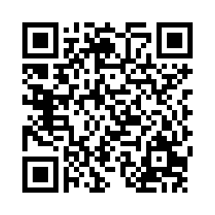

### Thank you!

We hope this toolkit supports you and your community. Please share your feedback!

* Scan the QR code in the toolkit
* [Or click this survey link](https://mdphhs.az1.qualtrics.com/jfe/form/SV_7NzKquF9Dz8x1Sm)

1. JG Research and Evaluation in collaboration with the MT Chronic Disease Prevention and Health Promotion Bureau
2. Video created by Mountain Pacific Quality Health, a regional Quality Improvement Organization.